37.7: 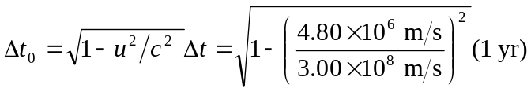
The least time elapses on the rocket’s clock because it had to be in two inertial frames whereas the earth was only in one.

